Name:_____________________
An english test for 5th grade 2014
- A. Write 5 sentences about the picture.
כתבו 5 משפטים על התמונה. שימו לב לשימוש נכון בכללי הדקדוק והכתיב.
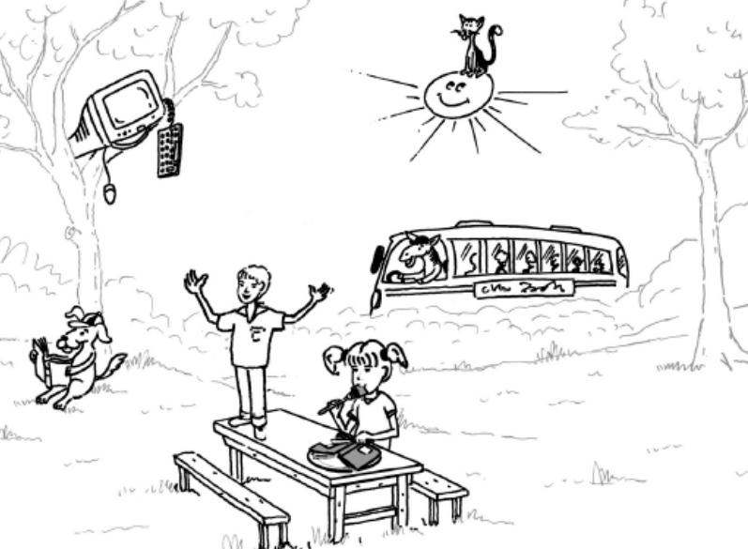

___________________________________________________________________________________________________________________________________________________________________________________________________________________________________________
B. Write 3 things you like to do with your friend:
_____________________________________________________________________________________________________________________________________________
Checklist רשימת בדיקה:* השתמשתי באות גדולה בראש כל משפט ובנקודה בסופו* התיאורים מתאימים לתמונה * השתמשתי נכון ב- There is\there are- have\has *כתב יד ברור ונקי
- Categorize:

recycle-
earth-
make-
choice-
save-
life-
live-
better-
alone-
fast-
hunt-
terrible-
scary-
mean-
Adjectives | Verbs | Other

- Complete.
- He _________________ (clean) for Pesach every year.
- She ________________ (drink) cola .
- We _________________ (not eat) bread on Pesach.

- Write: he\she\it\you\they
A zebra______ a cat and a dog_______ my father_______ animals______
Shira and I _______ mother________ you and your sister_______
The lion and the cow- a story
- Who?
- ____________ran away from the lion.
- ____________ is smart and helpful.
- The ____________ and the _________lived in peace.
- Answer in English.
- When was the cow happy? And when was it sad?
___________________________________________________
- The animals don’t want to help the cow. Why?
___________________________________________________Who is the best animal? Why?
__________________________________________________
- Write Yes\No
_______ The dove is strongest animal.
______ The elephant is scared as much as the giraffe.
______ The elephant is bigger than the lion.
- Order
סדרו את אירועי הסיפור כפי שקרו
- the cow was friends with the dove.
- The cow went to the giraffe for help.
- The elephant told the cow to go away.
- The cow was under a tree and very sad.
- The cow went to the elephant for help.
- The giraffe told the cow to go away.
- The lion was angry and wanted to eat the cow.
- The dove told the cow she will help.
- The lion ran away and fell into a hole.
- The dove pecked the lion on the head.
Good luck!!

