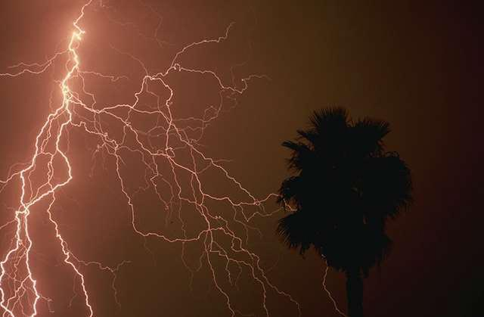
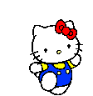
Sunglasses
Scarf
Boots
Socks
Cap
Shirt
Wool hat
Fan
Shorts
Shirt
Dress
Gloves
Shoes
Dress
Ribbon
Hat
Vest
WINTER
Help to the Helokitti to arrive to the winter through the winter clothes!
Bow
Umbrella
Sandals
Boots
Coat
Sweater
Scarf

